Quadrilaterals
A quadrilateral is a polygon with four sides, four angles and four vertices.
Properties of Square:
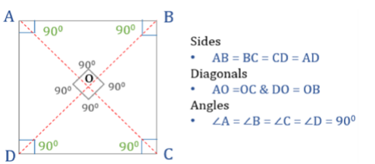
Sides:
- All four sides are equal.
- Opposite sides are parallel.
Angles:
- All four angles are right angles (90° each).
- Sum of interior angles = 360°
Diagonals:
- Diagonals are equal in length.
- Diagonals bisect each other at right angles (90°).
- Diagonals bisect the angles of the square.
Symmetry:
- A square has 4 lines of symmetry.
- (can rotate 90°, 180°, 270°, 360° and remain the same).

Properties of Rectangle:
1) Opposite sides are equal in length and parallel.
2) All corner angles are 90°.
3) Diagonals bisect each other.
4) Diagonals are equal in length.
5) 4 isosceles triangles are formed due to diagonal bisection.
